Ideation Phase
Empathize & Discover
Date 7-7- 2026
Team ID
Project Name Optimizing user, group and role
management with access control and
workflows
Maximum Marks 4 Marks

Empathy Map Canvas:
An empathy map is a simple, easy-to-digest visual that captures knowledge about a user’s
behaviours and attitudes.
It is a useful tool to helps teams better understand their users.
Creating an effective solution requires understanding the true problem and the person who
is experiencing it. The exercise of creating the map helps participants consider things from
the user’s perspective along with his or her goals and challenges.
The empathy map helps understand the needs of stakeholders such as system administrators, managers, and end users.
Target Users
• System Administrators
• IT Security Teams
• Managers/Approvers
• End Users (Employees)
Empathy Map
Thinks
• Access management is time-consuming
• Manual permissions are risky
• Need better visibility of user access
• Compliance requirements are increasing
• Want automation to reduce workload

Sees
• Multiple disconnected systems
• Frequent access-related tickets
• Permission conflicts
• Security audit pressures
Says
• "Access requests take too long."
• "We need centralized control."
• "Manual role assignment causes mistakes."
• "Audits are difficult to handle."
Feels
• Frustrated with manual processes
• Worried about security breaches
• Overloaded with administrative tasks
• Concerned about compliance failures
Example:
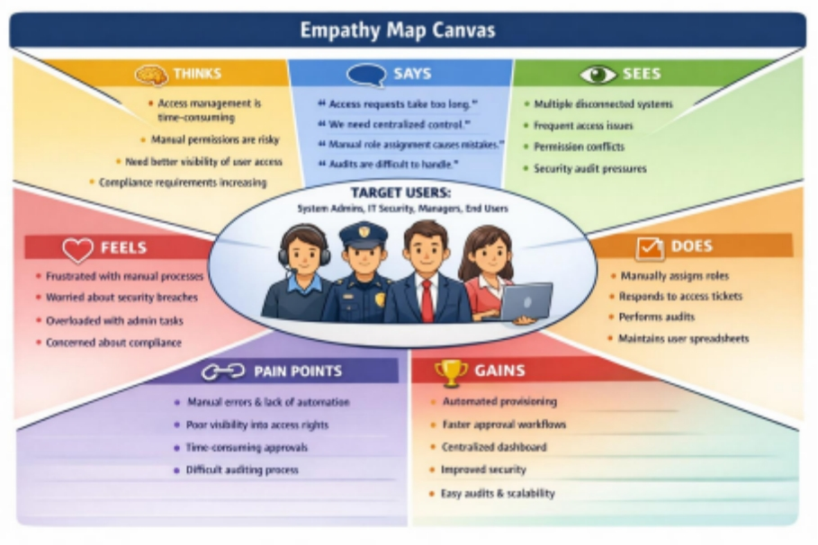

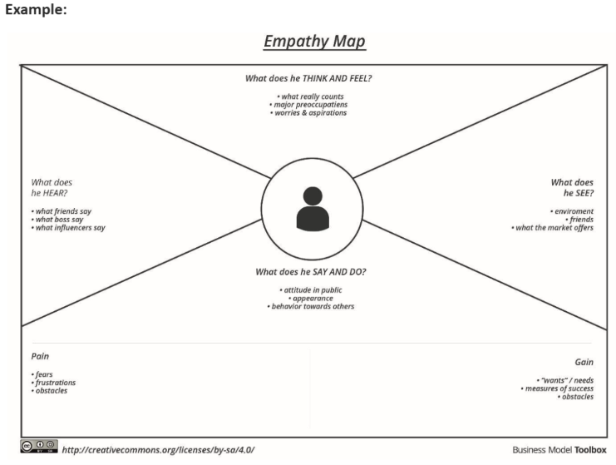
Reference: https://www.mural.co/templates/empathy-map-canvas
